ESG 101 Training

- In 2004 the ESG accronym is born.
- 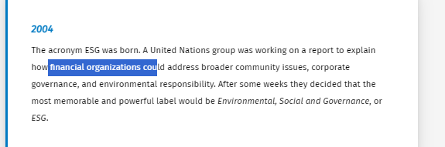
- Sustainable business or ESG-investing means adding value with consideration of the environment and human well-being, as well as the economy.
- ESG Reporting : focus on report
- ESG Investing with a focus on Investors’ point of view.
- ESG Ratings with a focus on how to score and measure ESG perofmrnace
- 3 Pillars
  - Environment : Conservation of the natural world:
    - Climate change
    - Carbon foorprint
    - Air and water pollution
    - Natural resource stewardship
    - Water stress
    - Biodiversity
    - Energy efficiency
    - Waste management
    - Management of dangerous substances
    - Compliance with governmental environmental regulations
    - And so forth
  - Social: Consideration of people & relationships:
    - Data protection and privacy
    - Gender diversity and equity
    - Employee engagement
    - Community involvement
    - Human rights
    - Labor standards
    - Customer satisfaction
    - And so forth
  - Governance
    - Disclosing of fair & transparent management information:
    - Board composition
    - Transparency in decision making of the board of directors
    - Audit committee structure
    - Bribery and corruption
    - Executive compensation
    - Lobbying
    - Political contributions
    - Whistle-blower schemes
    - And so forth

Environmental: a corporation’s responsibility towards nature
- Activities under Environmental part of ESG Energy, Carbon, emissions, uses of nature resources, waste management,..
- Most visible pilar to the average person.
Social Pressure:
- Societal pressure has led corporations to be more open about their energy consumption and provide a better insight on the use of renewable source
- Most of the entities now have a CSO
The environmental pillar is an important and publicly visible component of the daily responsibilities of all organizations.

Social : A Corporation’responsibility towards all stakeholders
The S in ESG = Social
- Activities: Positive community involvement, diversity and equity
- Permit to show to the company stakeholders that they have more responsibility to more stakeholders than just the company owner -Customer, suppliers employees, local and regional community.
- Idea behind :
  - Risk
  - Labor conditions
  - Positive engagement : Set of stakeholders that goes behond the owner of the company.

Governance :
- Governance activities that fall under the heading ESG include transparency in decision-making, board of directors composition, fair compensation, ethical business practices, and so forth.
- Good governance> Organisational structure, having all the different entitiys parties involved
  - Can involved, race, gender identity,..
- Move the company toward more inclusive and transparent decision making.

What are the company actually doing

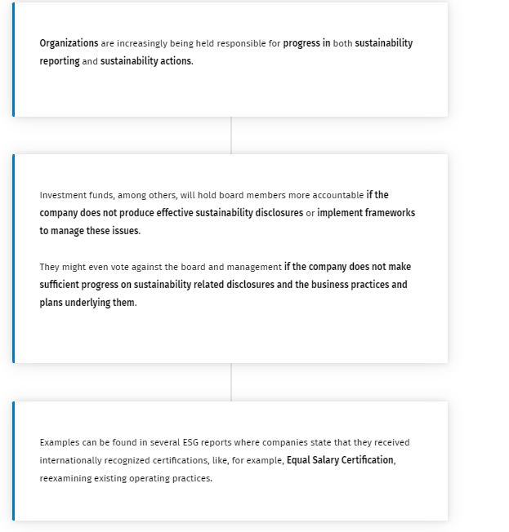Decarbonization
It is a key factor in E pillar.
This is divided into three different scopes:
- Scope on emissions These are caused by company activity such as emissions from vehicles and facilities. These emissions are the easiest to measure as they are directly traceable to a company’s activities.
- Scope two emissions : Emission in the production of energy (ex : Electiricity purchased and used by company), less measurable because those emissions needs to be process
- Scope Three Emissions:Emissions in all other parts of a company value chain.
- 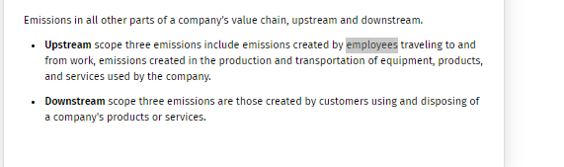
  - Upstream :
  - Downstrean
There are at least four approach to reduce carbon emission:
- Carbon reduction
- Carbon offset : planting trees
- Carbon credits :Carbon credits are related to carbon offsets, which are tradeable certificates that a high carbon generating company can buy from a low carbon generating company. An example of this system is the European Union Emissions Trading System.
- Carbon Capture: The most ambitious tool for decarbonization is carbon capture. This is a process of capturing emissions that would otherwise be released into the atmosphere and injecting them for example into deep geological formations for safe and permanent storage.

ESG Social Pillar

Within the social pillar of ESG, we will find the creation of responsible supply chains, ethical and sustainable raw material acquisition, environmentally sound production, and human labor conditions.
Companies can leverage their influence with suppliers to push for more positive social changes, including human rights and labor conditions.
Let's give some examples of how to promote a respectful business:
- Fair Trade
- Third party audit
- Members diversity

ESG Reporting Overview:

Managing Corporate risk exposure
- BAD ESG Report:
  - Lack of verified data
  - Opinions dreans or guesses
  - Lack of goals and no evidence of planning
  - Vague and complicated facts indicates the company is not really interested in providing stakeholders with ESG information
- Godd ESG Report: has four area covered
  - Opportunity
  - Sustainability
  - Community
  - Ethics and integrity

Different sets of ESG reporting around the globe :

Credible ESG reporting requires practicing increased internal commitment to ESG practices and exposes companies to external scrutiny of their ESG practices.
- The most commonly used ESG reporting frameworks are:
- The United Nation's Sustainable Development Goals: 17 goals set in 2015, the reporting focus on those goals.
- The Task Force on Climate Related Financial Disclosures: More climate related issues

- Global Reporting Initiative (GRI)
- Sustainability Accounting Standards Board (SASB)
- International Sustainability Standards Board (ISSB)
Also EU taxonomy

ESG Integrated reporting

Integrated Reporting

Integrated reporting (IR) is a well-known voluntary framework to create sustainable added value as a company. It is also part of the concept called “Integrated Thinking”
It brings together material information about an organization’s strategy, governance, performance, and prospects in a way that reflects the commercial, social, and environmental context within which it operates.
Two proven standards:
- GRI : Provided by global reporting initiative
- SASB Provided by value reporting foundation

GRI standards
- Modular system of interconnected standards .
- Help business and other organizations take responsibility for their impacts by providing them with a global language to communicate them.
- Allow organization to publicly report the impact of their activities in a structured way that is transparent to stakeholders and other interested parties.
- GRI standard system comprises three series of standards
  - GRI universal
  - GRI sector
  - GRI topic

GRI Universal Standards
- They strengthen the very foundations of all reporting through GRI, delivering the highest level of transparency for organizational impacts on the economy, environment, and people
- GRI1 Foundation :
  - It also specifies the principles – such as accuracy, balance, and verifiability – fundamental to good-quality reporting.
  - It outlines the purpose of GRI Standards, clarifies critical concepts, and explains how to use the Standards.
- GRI2 It contains disclosures relating to details about:
  - an organization’s structure and reporting practices
  - activities and workers
  - governance
  - strategy
  - policies
  - practices
  - stakeholder engagement
  - This give insight to the orgnaisation profile and scale and help in providing a context for understanding an organization impact
- GRI3 0 Material topic
  - It explains the steps a company needs to take to determine the topics which are most relevant to its impact and its material topics, and describes how the Sector Standards are used in this process.
  - It also contains disclosures for reporting:
    - Its list of material topics
    - The process
    - How it managed each topic

GRI Standard
- They are designed to help identify a sector's most significant impacts and reflect stakeholder expectations for sustainability reporting.
- They describe the sustainability context for a sector, outline organizations' likely material topics based on the sector’s most significant impacts, and list disclosures that are relevant for the sector to report on. They intend to increase the quality, completeness, and consistency of reporting by organizations.
- They contain disclosure for providing information on topics:
  - An organization has to choose those topics Standard that corresponds to the material topics:
    - Economic Topics
    - Environmental Tipics (Energy, Material, Water and effluents,.)
    - Social Topics(Employment, Labor, occupation Health and Safety)

GRI Standard report
GRI Standards can be used as a set to prepare a sustainability report or to respond to emerging regulatory disclosure needs, such as the EU Corporate Sustainability Reporting Directive and IFRS plans for enterprise value standards that are in accordance with the Standards.
2 Options for preparing a report :
- Core : contains the minimum information needed to understand the nature of the organization, its material topic and related impacts
- Comprehensive: This builds on the core option by requiring additional disclosures on the organization’s strategy ethics and integrity and governance. Moreover, the orga needs to report more on its impact by reporting all topic specific disclorsures for each material topic covered by the GRI standards.

Value reporting Foundation
The value reporting foundation is a global non profit orga that offers a comprehensive suite of resources designed to help businesses and investors develop a shared understanding of enterprise value: how it is created, preserved, and eroded.
Value Reporting Foundation was formally known as the International Integrated Reporting Council (IIRC) and the Sustainability Accounting Standards Board (SASB) which was founded in 2011 and focuses on industry-specific sustainability reporting issues.
The SASB differentiates itself with its practical focus on financially material, industry-specific, decision-useful, cost-effective, evidence-based, and market-informed sustainability disclosures.
SASB Standards enable organizations to provide industry-based sustainability disclosures about risks and opportunities that affect enterprise value. They identify the subset of environmental, social, and governance issues most relevant to financial performance and enterprise value for 77 industries belonging to different sectors

SASB Standards
- SASB can be used with other frameworks and standards.
- They are practica tool for impleeting principles based frameworks (also the one provided by TCFD)
- Many companies use SASB and GRI standards to meet the nees of various stakeholders
- The use of SASB is voluntary
- Each SASB includes:
  - Disclosure topics
    - Disclosure Topics : A minimum set of industry-specific disclosure topics reasonably likely to constitute material information, and a brief description of how management or mismanagement of each topic may affect value creation.
    - Accounting Metrics A set of quantitative and/or qualitative accounting metrics intended to measure performance on each topic.
    - Technical Protocols: Each accounting metric is accompanied by a technical protocol that provides guidance on definitions, scope, implementation, compilation, and presentation, all of which are intended to constitute suitable criteria for third-party assurance.
    - Activity Metrics :A set of metrics that quantify the scale of a company’s business and are intended for use in conjunction with accounting metrics to normalize data and facilitate comparison.

ESG Regular Reporting standards

Regular reporting standards
- Most used reporting standards:
  - EU: Corporated sustainability reporting directive (CRSD)
  - EU: Non financial reporting directive(NFRD)
  - IFRS : International sustainability standards board (ISSB)
- ESRSs (European Sustainability Reporting Standards), developed by EFRAG (European Financial Reporting Advisory Group), are standards that define the detailed disclosure requirements under CSRD (Corporate Sustainability Reporting Directive).
  - strengthen the rules that companies must report (regarding E and S)
  - The new rules will ensure that investors and other stakeholders have access to the information they need to assess investment risks arising from climate change and other sustainability issues.
  - Create a clture of transparency about the impact companies on people and the environment.
  - Reporting Cost will be reduced for companies over the medium, long term.
Companies subject to CSRD will have to report according to European Sustainability Reporting Standards (ESRS). The draft standards are developed by the EFRAG, previously known as the European Financial Reporting Advisory Group, an independent body bringing together various stakeholders. The standards will be tailored to EU policies while building on and contributing to international standardization initiatives.
On 6 June 2023, the Commission opened a four-week public feedback period on the first set of sustainability reporting standards for companies. These draft standards take account of technical advice from EFRAG in November 2022.

Following the feedback period, the Commission will consider the feedback received before finalizing the standards as delegated acts and submitting them to the European Parliament and Council for scrutiny.
The EU Commission adopted the draft standard on July 31st. The first set of 12 ESRSs has been submitted by the EFRAG to the European Commission.
They are divided into two “cross-cutting standards” and ten “topical standards”.
The former is used to define the general requirements that apply to all the topics subject to CSRD, to provide principles of disclosure and presentation structure, and to establish transitional provisions.

The latter provides metrics for the environmental, social and governance aspects of CSRD and topic-specific application guidance on governance, strategy, impact, risk, and opportunity management.

CRSD in Detail
- Double materiality
  - Impact Materiality ity requires disclosure of sustainability matters that relate to companies’ material actual or potential, positive, or negative impacts on people or on the environment over the short, medium, and long term.
  - Financial materiality requires disclosure of sustainability matters that trigger or may trigger material financial effects on companies’ development (e.g., cash flows, financial position, financial performance) in the short, medium, and long term.
- Inclusion of prospective information
- Upstream and downstream value chain : To disclose ESG impacts over companies entire value chain, considering for example suppliers and customers
- Sustainability due to diligence: Related to the corporate sustainability due diligence directive.
The CRSD companies needs to disclose :
- 3 Topics:
  - E
  - S
  - G
- 4 Reporting Areas
  - Governancebad ESG

  - Strategy
  - Impact, risk, and opportunity management
  - Metrics and targets
- 3 Reporting Layer
  - Sector =agnostic: Disclosure applying to all companies, for maximum comparability
  - Sector specific disclosure requirement applying to companies of a specific sector for maximum relevance
  - Company specific additional disclosure requirements on material impacts, risks, and opportunities not covered by topical standards

CSRD has been designed to ensure it supplements EU Taxonomy. According to EU Taxonomy, companies falling within the scope of the existing NFRD are expected to report on the extent to which their activities are sustainable. The indicators for this requirement will be specified in a separate Commission Delegated Act, in alignment with SFDR and existing EU Taxonomy requirements.

EFRAG is working with international bodies to align ESRS with international standards (e.g., TCFD, ISSB, GRI, etc.) to reduce the compliance burden of entities’ sustainability reporting. Companies shall compare existing and applied frameworks by aligning definitions and methodologies, reassessing the materiality, identifying, and assessing gaps, and expanding the reporting boundaries.

Compared to the GRIs, ESRS disclosure requirements are partly based on GRI. It is possible to include disclosures based on GRIs when developing company-specific disclosures.

EU : Non financial reporting Directive

The rules introduced by the Non-Financial Reporting Directive (NFRD) remain in force until companies have to apply the CSRD new rules.
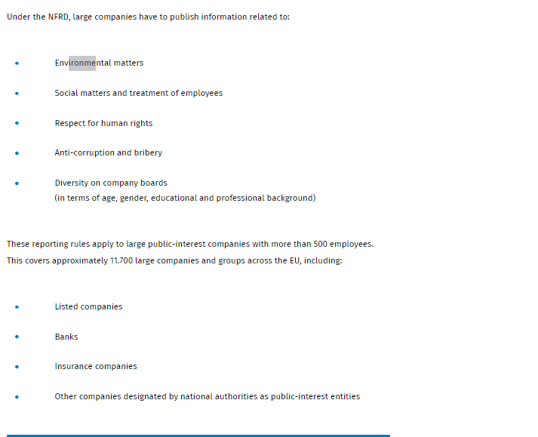

IFRS: International Sustainability standards Boards (ISSB)
- Created in 2021
- Want ot merge the SASB into the ISSB to go to one global reporting framework for ESG reporting.
- This will be compulsory in the future

EU Taxonomy for sustainable activities
- The EU taxonomy is a classification system, published by the Technical Expert Group on Sustainable Finance, establishing a list of environmentally sustainable economic activities.
- This tool provided companies, investor and policymakers with appropriates definitions, a common language with clear definitions, which define which economic activities can be considered environmentally sustainable.
- Want to protect from greenwashing investors
- More climate friendly companies
- Six environment objectives:
  - Climate change mitigation
  - Climate change adaptation
  - Sustainable use of water and marine resources
  - Circular economy
  - Pollution Prevention
  - Healthy ecosystem
- The EU taxonomy is a green classificaction system that translated the EU’s climates and environmental objectives into criteria

When is an activity sustainable
- Activities include in EU taxonomy
  - Activities that contribute substantially to one of the six environment objectives
  - Transition activities : N echnologically and economically feasible low carbon alternatives but that support the transition to a climate neutral economy, in a manner that it limites the the increase to 1,5C above pre-industrial level.
  - Enabling activitie sthey enable other activities to make a substantial contribution to one or more of the objectives and do not lead to a lock-in in assets that undermine long-term environmental goals, considering the economic lifetime of those asset
- Taxonomy eligibility
  - activity is included in the delegates act on climate change mitigation of climate change adaptation.
- Taxonomy alignment
- Substantial contribution
  - To align with the taxonomy, the first criteria of the activity is to substantially contributes to at least one of the EU climate and environmental objectives, ensuring that the economic activity either has substantial positive environment impact or reduce negative impact on the environment’
- Do no significant harm principle
  - Has not to harm other objectives. (second criteria)
- Minimum safeguards
  - (Third Criteria) qualify the economic activity as environmentally sustainable, this activity has to be conducted with minimum safeguards.
  - They are procedures that an undertaking shall implement to be aligned with minimum international human rights standards when providing products and services.
- Technical screening criteria
  - (add to the 4 previous principles)
  - Aim to define specific technical details to assess the short and long term environmental impact of economic activity by establishing and regularly updating the confitions through which it can meet the requirement of substantial contribution and do not significan harm principle.

Taxonomy User

Large financial and non-financial companies that fall under the scope of the Non-Financial Reporting Directive (NFRD), currently in revision as the Corporate Sustainability Reporting Directive (CSRD), will have to disclose to what extent the activities that they conduct meet the criteria set out in the EU Taxonomy.
Likewise, financial market participants (such as asset managers) will have to disclose to what extent the activities that their financial products fund meet the EU Taxonomy criteria. Companies will be able to disclose the extent to which they invest, for example:
- through capital expenditures
- in either expanding or strengthening their activities which are already Taxonomy-aligned
- to upgrade other activities to make them Taxonomy-aligned
The Taxonomy Regulation requires the Member States and the EU to use the EU Taxonomy as the basis of any EU or national (public) labels for green corporate bonds or financial products that fall under the scope of the Sustainable Finance Disclosure Regulation (SFDR).
The EU Taxonomy therefore provides a good basis for the development of further sustainable finance tools, including the EU Ecolabel for Retail Financial Products and future EU standards for green bonds (all under development) as well as green mortgages.
The Taxonomy Regulation identifies three macro-groups of Taxonomy users

Area of applicability
Non financial undertakings
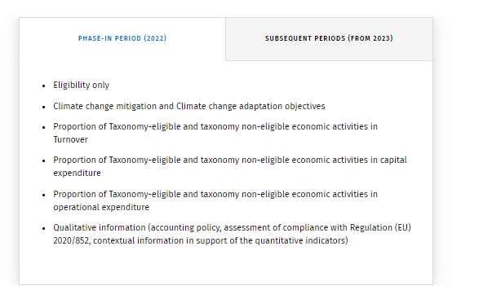
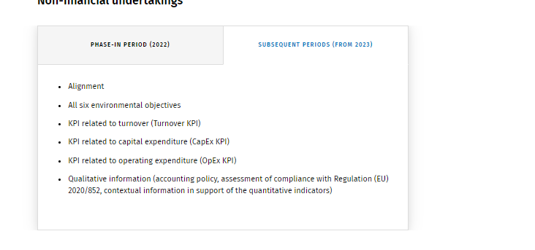Credit institutions

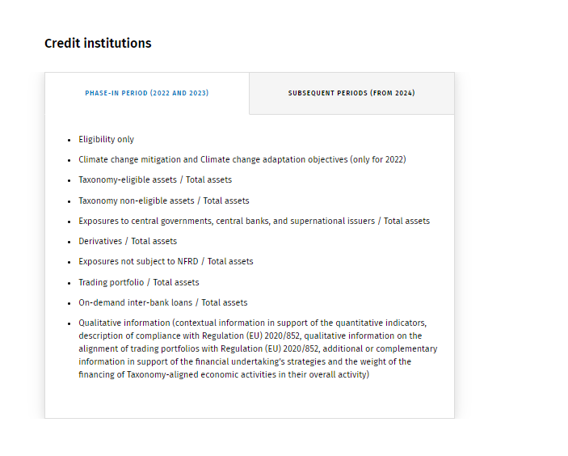
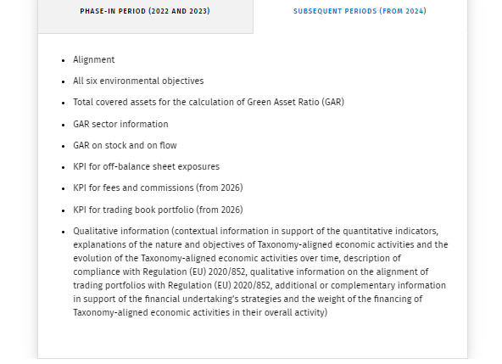
Insurance and reinsurance undertakings
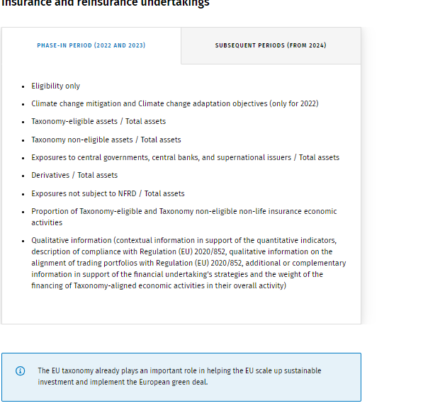

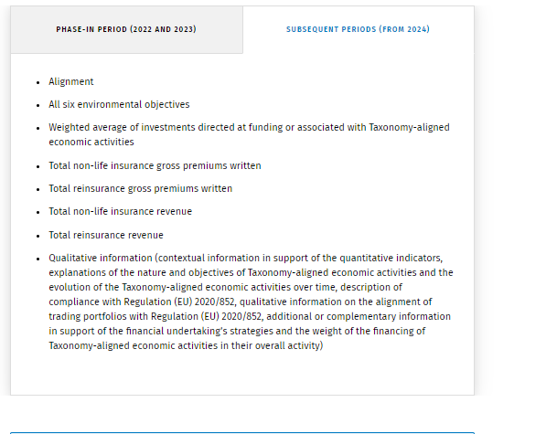

Introduction to CCH Tagetik ESG & Sustainability solution

Why
- 4 major reasons :
  - Drive a sustainable future Improve ESG Plans and understand ESG impacts
  - Build Trust
  - Get compliant (compile with ESG regulations)
  - Integrate financial and non financial Data ( Integrate ESG strategy into all financial processes, Use one strategic and intelligent finance transformation platform to support all your decisions. )

Why
But of course, implementing an ESG & Sustainability solution within a company will be done following a multidisciplinary approach.

What
CCH Tagetik offers an ESG & Sustainability Performance Management solution, which is integrated in our strategic & financial intelligent platform.
One platform
CCH Tagetik offers an ESG & Sustainability Performance Management solution, which is integrated in our strategic & financial intelligent platform.
This means that ESG & Sustainability Performance can be managed in CCH Tagetik, like all other processes of the office of finance. From Supply chain planning via Financial close & consolidation to Regulatory compliance.
Financial and non-financial convergence
The basic idea is to create a solution that enables our customers to build trust and sustainably grow their business over the long term easily connecting non-financial data with financial performance.
As you can see in the image below, from a non-financial perspective, this solution provides Climate data, Environmental & social performance, as well as Risk indicators & KPIs.
In addition to these elements, we have enriched our solution with all the other relevant financial components.

Three Steps
- CCH Tagetik covers the ESG & Sustainability process end to end
  - Data Collection & Normalzition
  - Process Monitoring &Calculation
  - Disclosure & Reporting

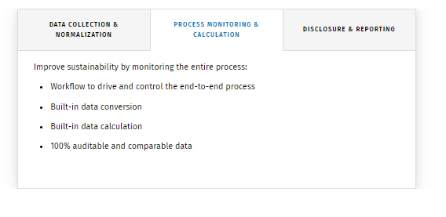
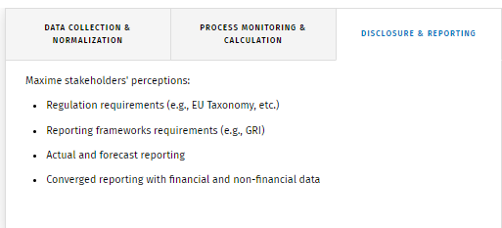

How
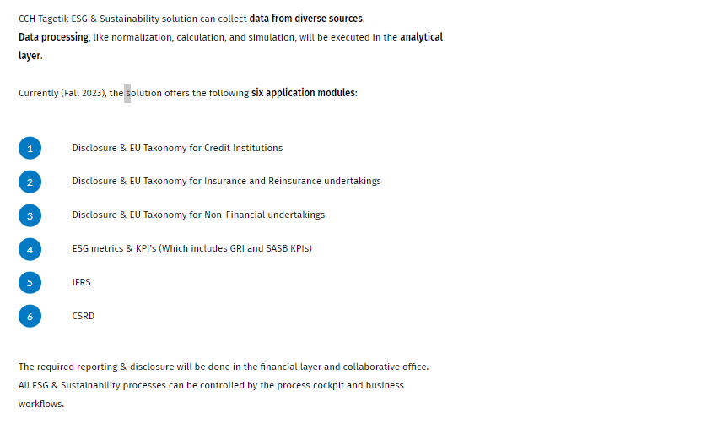
Data processing is made on the Analytica layer.
The reporting &Disclosure will be done im the financial layer and collaborative office. All ESG sustainability processes can be controlled by the process cockpit and business workflow.

How to use disclosure &EU taxonomy for Credit institutions
Major application modules:
- Disclosure & EU Taxonomy for Credit Institutions
- Disclosure & EU Taxonomy for Insurance and Reinsurance undertakings
- Disclosure & EU Taxonomy for Non-Financial undertakings
- ESG metrics & KPI’s
- IFRS
- CSRD
In this section we will lok into : Disclosure &EU taxonomy for credit institutions
Here is the workflow that would be for requirement from the 2023 reporting data :

Consultation
Six environmental objectives
- Climate change mitigations
- Climate change adaptation
- The sustainable use and protection of water and marine resources
- The transition to a circular economy
- Pollution prevention and control
- The protection and restoration of biodiversity and ecosystem
Two standard reports provide insight into these updates. Additionally, it is possible to consult the EU Taxonomy Credit Institutions data model, to verify how to upload data into the Solution.
No end-user activity is required, but it is an optional and read-only step that represents a regulatory consultation phase.
The administrator can define which counterparts are located in a European Union country by using the standard codes provided by the Solution, or by using custom internal codes. Of these counterparts, their Business Activity Codes should be associated with specific counterpart categories, again by using standard or custom codes.

The bank’s internal economic activity code needs to be associated with the NACE code, using standard or custom coding.
The solution requires the Capex and turnoved percentages for both the eligibility and the alignment process associated with issuers must be collected.

Settings

Within this step, the administrator also defines which NACE codes are eligible for climate mitigation and climate adaptation objectives according to the EU Taxonomy regulation.
A listing should be provided for companies that are subject to the Non-Financial Disclosure and for issued green bonds.

A mapping is for example also needed for the following:
- Category mapping
- Attributes mapping
- GAR_MAPPING
- Some other pre configuration report will need to be done.

Data collection

You need to load the following items:
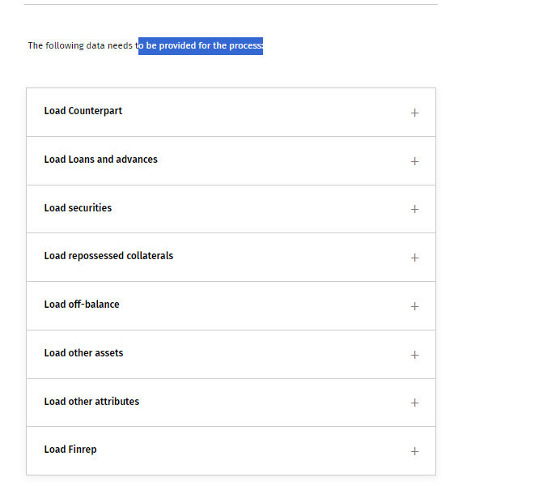

- Load counterpart
  - Entity counterparty
- Load Loans and advances
  - The list of loans and advances issued by the bank, reporting their gross carrying amount, their internal identifier code, the indication if they are included in the trading portfolio or not, and the eligibility and alignment percentages of exposures for which the use of proceeds is known.
- Load securities
  - The list of debt securities and equity instruments held by the bank, reporting their gross carrying amount, their internal identifier code, the indication if they are included in the trading portfolio or not and the eligibility and alignment percentages of exposures for which the use of proceed is known.
- Load reprossesses collaterals
  - The list of real estate collaterals which the bank has acquired following the counterpart non-payment of debts, reporting their gross carrying amount, their internal identifier code, and the eligibility and alignment percentages of exposures for which the use of proceed is known.
- Load off balance
  - The list of off-balance exposure held by the credit institutions (e.g., financial guarantees and assets under management).
- Load other assets
  - All other assets held by the bank that are outside the eligibility considerations (e.g., derivatives, trading book, cash, etc.).
- Load other attributes
  - Other relevant information related to credit institution’s exposures and also information related to EBA’s Pillar 3 disclosure.
- Load FINREP
  - Data coming from financial reporting in order to perform balances with ESG data or leverage already certified financial data into ESG templates. It is possible to upload original and consolidated data divided by single contributor entity and by category or upload financial consolidated data into a single fictitious legal entity (GROUP) representing the whole group.
For consolidation purpose, it is required to collect the counterpart data.
Data entry forms give the possibility to modify/add the data directly from the partition without re-uploading the files.

Data Quality
- For each input dataset the solution performs the following checks:
  - Closed Lists : Input elements mst be included in the allowed values of dictionaires provided by the solution
  - Key existence : A Key field must always be uploaded in input files
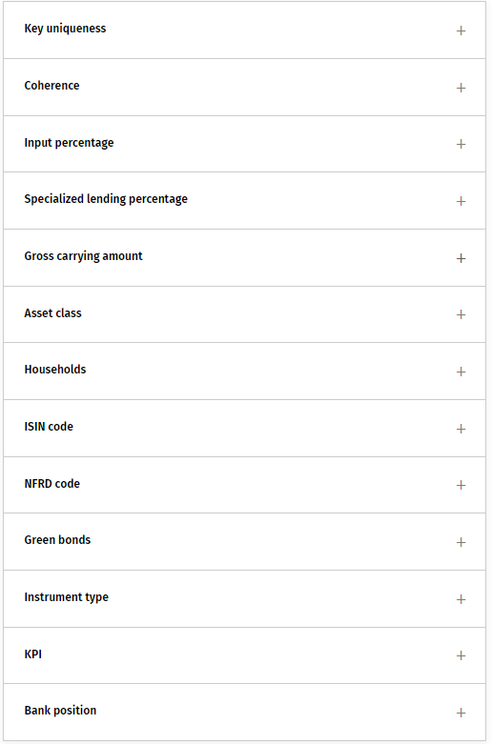

KPI Calculation
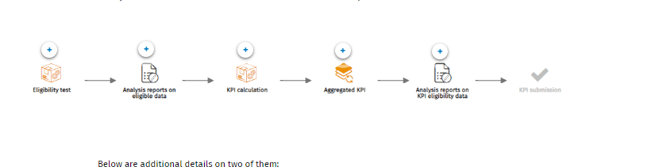

Eligibility test
- In this step, it is possible to run the eligibility test at the counterpart level and calculate the eligible amount of a single loan and advance, debt security and equity instrument, and repossessed asset held by the bank.
- The counterparts who do not meet these criteria are not eligible for climate mitigation and climate adaptation objectives.
- The same eligibility tests are performed in advance at single record (single loan and advance, single security, single repossessed collateral) level if NACE or external data information is available at a more granular level. For records not covered by the granular eligibility test, the Solution will apply the eligibility result obtained from the eligibility test at counterpart level. At the end of the phase, all records will have an eligibility result (YES/NO) that will drive their disclosure in output reports.
- The Solution provides a check that shows possible counterparts deemed eligible for climate mitigation and climate adaptation objectives according to KPI eligibility test or according to information provided in input, but who would have failed the NACE eligibility test as their NACE code is not included in the EU Taxonomy.

KPI Calculation
The Solution aggregates the instruments included in the KPI Eligibility dataset in a tag (label) according to counterpart’s characteristics (e.g., counterpart category, inclusion in held for trading portfolio, headquarters located in an EU member country, etc.).
These tags are mapped and transferred to the financial layer to populate the desired output template (Assets for the calculation of GAR included in Annex VI of EU Taxonomy Delegated Act or Article 10 of the Disclosures Delegated Act) or to the two output templates at the same time for disclosure for year-end 2022.

GAR Calculation

- GAR Data preparation
  - Data preparation performs some enrichment of counterparts values from reference dataset and non-partitioned datasets, and some enrichments of single exposure records from Counterpart dataset. Further checks are performed on enriched data (e.g., coherence between counterpart category and asset class data, etc.). The records that fail the checks are excluded from subsequent steps.
- Analysis reports on elaboration data
  - For several of the enrichments, the results can be checks within the analysis reports on elaboration data tasks.
- GAR Calculation:
  - Calculation includes activities that are associated with each exposure held by the bank, not excluded by the elaboration for data quality defects, an account, a ESG disclosure dimension and a formula to be applied to the gross carrying amount, through the application of rules based on counterpart’s characteristics (e.g., counterpart category, inclusion in held for trading portfolio, headquarters located in an EU member country, etc.) and on eligibility and alignment percentages uploaded, and calculate a final output amount to be reported in disclosure templates.

Output
- 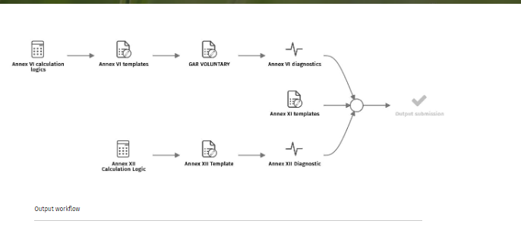
The reports are also editable to allow the user to make the data entry directly with the final results.

According to the choice made at the beginning of the process, it is possible to disclose data in a granular way according to the Template Asset for the calculation of GAR included in Annex VI of EU Taxonomy regulation, or in an aggregated way according to the Template Disclosure by credit institutions under Article 8 Delegated art 10 included in document Platform considerations on voluntary information as part of Taxonomy-eligibility reporting.

For year-end 2022 both reports are populated at the same time to cover the mandatory and voluntary disclosure with a match between tags generated in KPI calculation and related accounts included in a dedicated reference dataset.

The Solution provides some diagnostics that perform some control groups between accounts, re-proposing in the financial layer the same coherence checks of the checking rules in the analytical layer and included in the previous phase. The Solution also provides balancing controls between the values recorded in the two templates.

In output reports, it is possible to perform a drill-through activity to obtain the detailed breakdown underlying the aggregated KPIs.

Reporting and disclosure
The template for the disclosure are:
- Annex 6: templaes for KPIS of the credit institutions
- Annex 9: Quality disclosures for ssets managers, credit institutions, investments firms, and insurance and reinsurance undertakings
- Annex 12: Standard templates for the disclosure referred to nuclear and fossil gas related activities
It is also possible to create personalized reports for managerial purposes
The output templates coincide with those required by the regulation

Templates
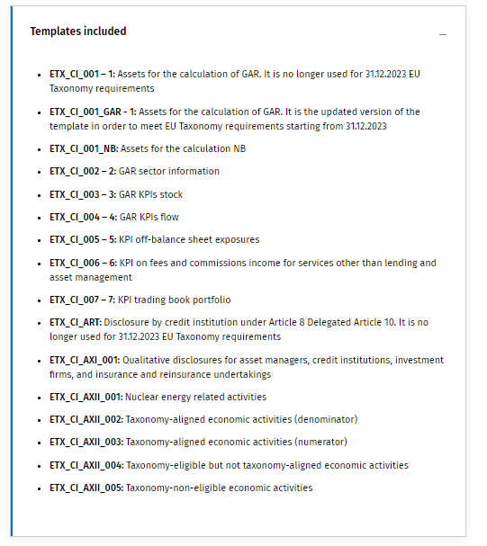
EBA Pillar 3 templates
The ESG Solution includes EBA Pillar 3 templates to disclose prudential information on environmental, social, and governance risks, including transition and physical risks.

Consolidation
It is not about a classic consolidated financial statement because balance sheet liabilities and P&L data are not required by EU Taxonomy Regulation, but Annex V of Delegated Act 2021-4987 requires that Credit institutions shall disclose relevant KPIs based on the scope of their prudential consolidation determined in accordance with Regulation (EU) No 575/2013.

A data model configuration for the consolidation has been performed, by defining for the original scenario the exchange rates (average FX rate generally used for P&L accounts, period FX rate generally used for P&L accounts for which a different FX rate in applied on periodic values, and final FX rate generally used for BS accounts, with the exception of the net equity accounts which are typically converted at the historical FX rate) for each currency and by defining some account elements (e.g., conversion type, enablement for IC management).
Below you can see the Consolidation workflow. Select each hotspot to know more about the tasks.
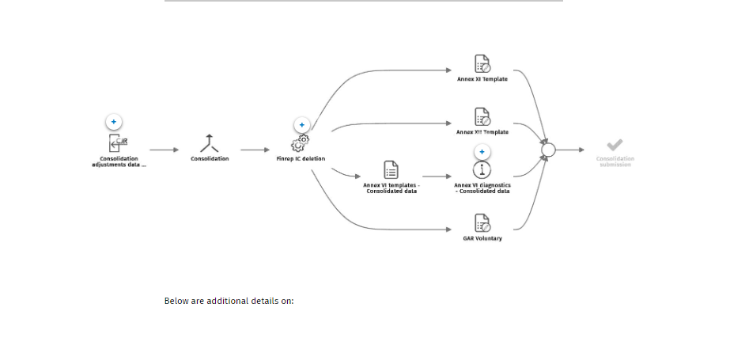

Group View
This last contributor step is only available for the entity representing the group, consolidated data are transferred to the Group Legal entity original data to recalculated the ESG KPI at group level, leveraging on the same calculation logics used at single contributor entity level.
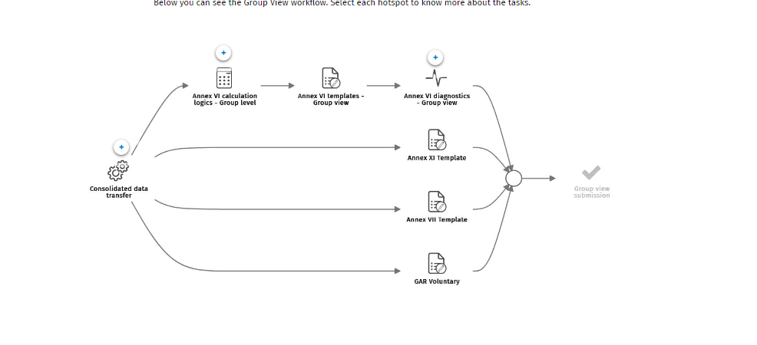

How to use disclosure &EU Taxonomy for insurance and reinsurance undertakings
In line with the regulation updates, we currently cover the first two objectives: climate change mitigation and climate change adaptation.
Two standard reports provide an insight into these updates. Additionally, it is possible to consult the EU Taxonomy for Insurance and Reinsurance undertaking data model, to verify how to upload data into the Solution.
No end-user activity is required, but it is an optional and read-only step that represents a regulatory consultation phase.
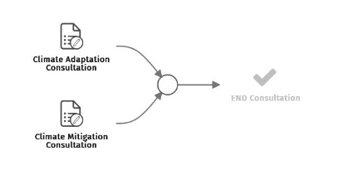

Settings
This setting phase involves the customer's own internal settings and these of the solution, aligned to the customer's needs.
The administrator can define which issuers are located within countries which are part of the European Union.
The insurance/reinsurance’s internal economic activity code needs to be associated with NACE code.
Within this step, the administrator also defines which NACE codes are eligible for climate mitigation and climate adaptation objectives according to the EU Taxonomy regulation.
A listing should be provided for companies that are subject to the Non-Financial Disclosure and for issued green bonds.
A mapping is also needed between tags generated by the Solution with combinations of account, ESG disclosure dimension, and category to produce the output reports.

Below are examples about the tasks:
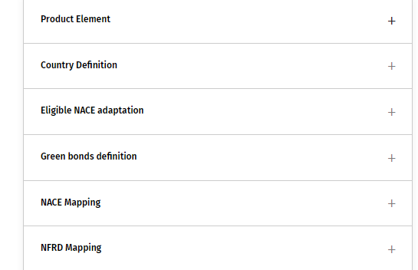

Data collection
We now need to load the data from the insurance/reinsurance source system
Need to provide the following data :
- Load External DataFrom external info-provides CapEx and Turnover percentages (for both the eligibility and the alignment process) associated with issuers.
- Load issues : The main information of entity issuers (e.g., name, identifier code, identifying code for issuers subject to NFRD to match with data coming from external info-providers, Business Activity Code, internal economic activity code to match with NACE code, identifier for the headquarter country location). It is essential in this file not to load duplicate data. The positions must be loaded only once and not with double amounts, so we will only have to record the amounts once, and then the system (thanks to the % in the external data file) will divide the values correctly.
- Load securities The list of debt securities and equity instruments held by the Insurance/Reinsurance, reporting their gross carrying amount, their internal identifier code, the issuers to which they are referred, and the indication if they are included in the trading portfolio or not. Also, in this input file, the same reasoning applies to "Issuers", so it is necessary to load the data only once to avoid duplication.
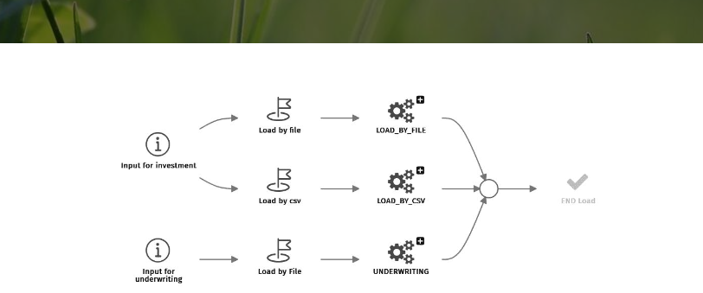

Data quality
- Some check on the data uploaded in the previous step
- (Same as the one done before)
- For each input dataset the solution performs the following checks:
  - Closed Lists : Input elements mst be included in the allowed values of dictionaires provided by the solution
  - Key existence : A Key field must always be uploaded in input files

KPI Calculation
The eligibility test includes activities that enrich the issuers' dataset with attributes from reference and non-partitioned datasets and other formulas and, thereafter, verify which issuers are eligible according to Climate Mitigation and Climate Adaptation matrices and, therefore, eligible according to EU Taxonomy requirements. The eligibility test is performed at different levels:
- Direct eligibility test : based on some issuers classifications
- KPI eligibility test: based on Capex and turnover percentages and reported by an info provider

The Issuers who do not meet these criteria are not eligible for climate mitigation and climate adaptation objectives.
The same eligibility tests are performed in advance for single security level if external data information is available at a more granular level. For records not covered by the granular eligibility test, the Solution will apply the eligibility result obtained from the eligibility test at issuers level. At the end of the phase, all records will have an eligibility result (YES/NO) that will drive their disclosure in output reports.

During the Eligibility Test phase, the system will also identify the positions not subject to the NFRD, associating the respective NACE code to be able to carry out the KPI Calculation phase also for Voluntary Disclosure.

Below you can see the KPI Calculation workflow. Select each hotspot to know more about the tasks. 
KPI calculation: In this task, we will also calculate the eligibility values for all those positions that do not fall within the Disclosure Mandatory. Thanks to a calculated amount and the NACE method, the NO NFRD and NO EU positions within the Voluntary Disclosure will also be included.
Aggregated KPI: The Aggregated KPI task will also transfer data from the analytical layer (AIH) to the financial layer (CPM) through the QDL tool applied to “The proportion of the insurance or reinsurance undertaking’s investments dataset”. The Solution provides the following configuration of dimensions and uses some default values for the Scenario, Period, Entity and Currency fields. At the end of the KPI calculation process, it is possible to check Investment Output results, both for mandatory and voluntary disclosure, on dedicated reports

Underwriting task

The task Underwriting calculation includes the activities necessary to calculate the premium eligibility percentage. Since the policy includes N guarantees, only the guarantee with Climate Perils is eligible.

Within the Aggregated Premium, the Solution aggregates the instruments included in Underwriting Output. These tags are mapped and transferred to the financial layer to populate the desired output template (Underwriting KPI for non-life insurance and reinsurance undertakings).

Compilance Criteria
Before the first task can be run, the administrator needs to configure the Minimum Social Safeguard Criteria questions in a dedicated report. Custom questions can also be set up. Saving the report will also run the Compliance Criteria task.

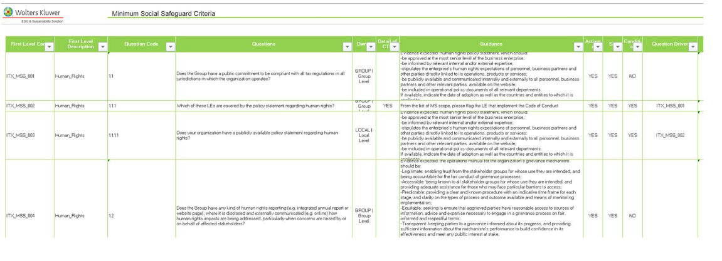
The compilance crteria wfl
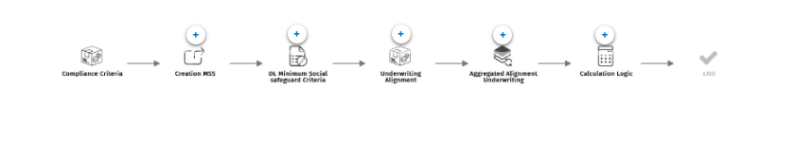

How to use Discolsure &EU Taxonomy for non financial undertakings ?

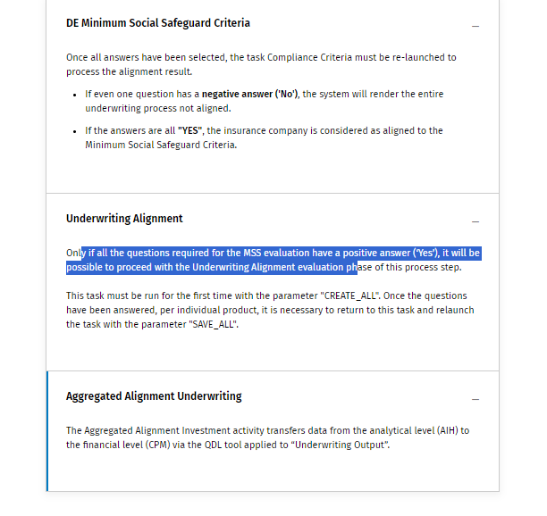

Investment alignment
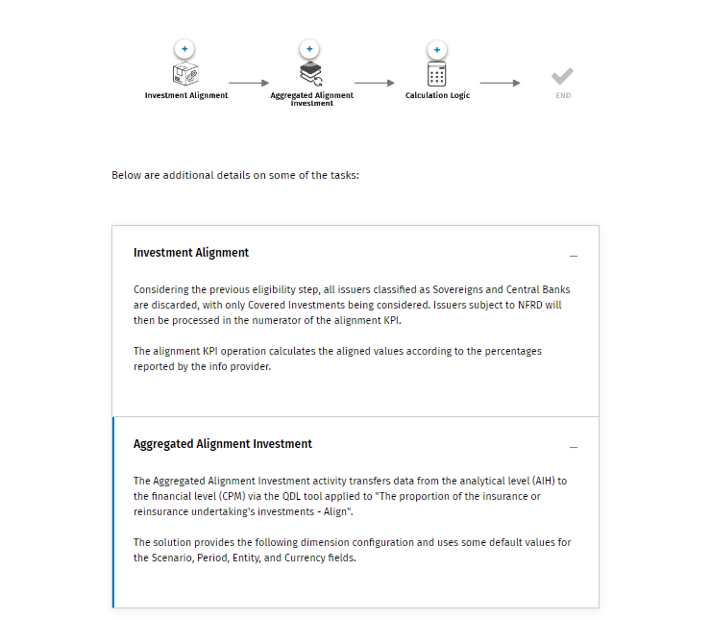

Reporting and disclosure
The ESG Solution provides reports in the financial layer for the mandatory templates required by the annexes of EU Taxonomy Delegated Act, for insurance and Reinsurance undertakings they are the following:
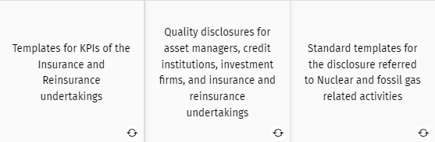

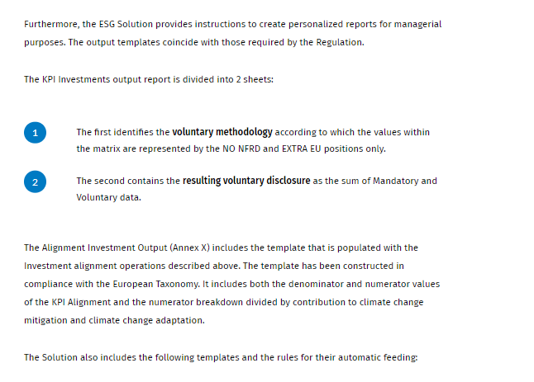
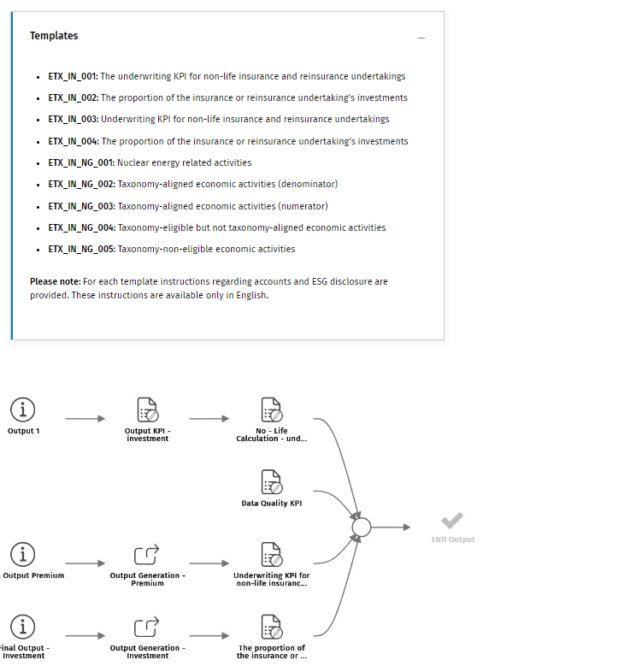
The Consolidation Adjustments data entry task allows the consolidator to enter manual adjustment entries to integrate the data and the journals generated by the Solution.
Thanks to the task Consolidation, the consolidation engine aggregates the data of individual entities creating the group company. This way, we will have the consolidated values for the parent company.

Group View
The task consolidated data transfer transfers the consolidated ESG data to the group legal entity.

How to use Disclosure &EU Taxonomy for non financial undertakings

Consultation
The Taxonomy Sectors and Codes and Eligibility report includes the mapping of the Taxonomy Codes associated with the related sectors and NACE codes provided by the EU Taxonomy regulation.
No end-user activity is required, but it is an optional and read-only step that represents a regulatory consultation phase.
The consultation report includes the mapping of the Taxonomy codes associated with the related sectors and NACE codes provided by the EU taxonomy regulation

Settings
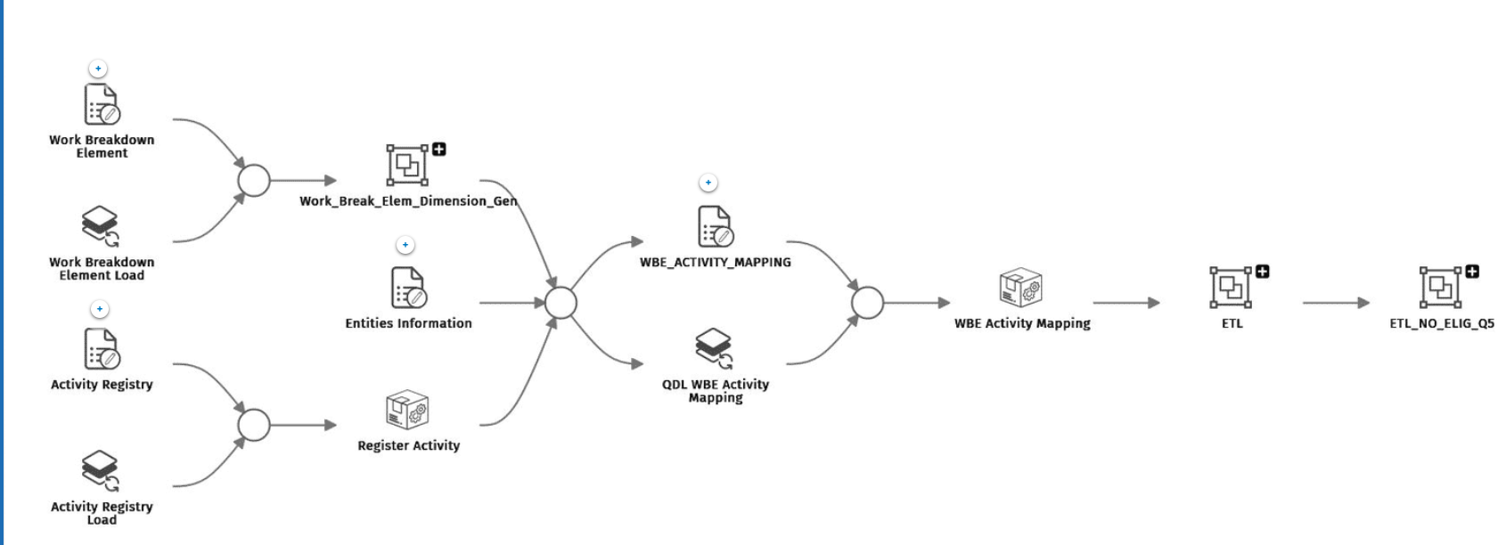

- Work Breakdown : Upload of the elements, dedicated to the upload of detail in the data contribution of each activity
- Entities information : 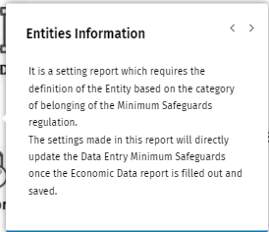
- WBE_ACTIVITY_MAPPING : Form dedicated to the mapping between the actvities and the work breakdown elements.
Work Break down element Tasks:
The upload of the level of detail of the Work Breakdown Element can be done either as manual data entry or via Quick Data Loader (QDL). Within the solution you can decide whether to use the WBE or not. It is not possible to make a mix, some activities set with WBE and others not. If for the same taxonomy code there are more WBE, it is necessary to set the activity that does not have WBE with NC.
Instead, it is possible not to set the WBE if there are some different activities which are only eligible and not aligned or non-eligible.
The report Entities Information is a setting report which requires the definition of the Entity based on the category of belonging of the Minimum Safeguards regulation. The settings made in this report will directly update the Data Entry Minimum Safeguards from once the Economic Data report is filled out and saved.

Activity Registry:
Within the Activity Registry, it is possible to add an activity based on the taxonomy and in "Activity code of the Entity" an internal activity code could be inserted which can also be different from the "Taxonomy activity code": it depends on the internal archive mode of every single entity.
Furthermore, the aim is to census economic activities without splitting them into aligned and eligible. So, in the Activity Registry report all the activities carried out by the Entity must be listed.
The activity codes and descriptions of the entity can be associated with one of the activity codes based on Taxonomy (in this case the activity will be considered in the category Eligible) or not (the activity not associated with a Taxonomy code is considered non-eligible) according to the EU Commission Delegated Act.
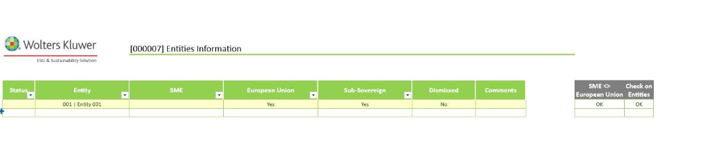

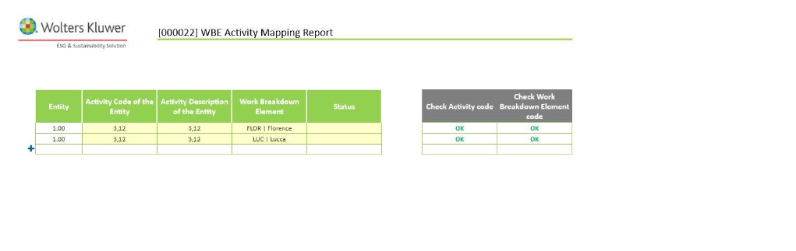

Data Collection
Load data from an internal or external source, this has to be done at entity level.
Data to collect:
- Economic data: data to calculate the different economic indicator: Turnover, capex, Opex for each activity set in the activity registry form.
- Previous Value data can also be taken (DTP)
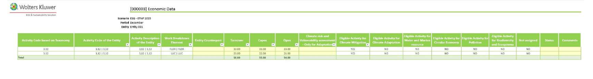

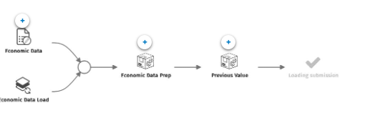

KPI Calculation:
Look if the loaded activities in the previous steps are eligible and are aligned.
An Activity is considered Aligned according to the Taxonomy regulation if it satisfies both the "Do Not Significant Harm" and the "Technical screening" criteria.
The reports DE - Climate Mitigation, DE - Climate Adaptation, DE - Water and Marine Resource, DE - Circular Economy, DE - Pollution, and DE - Biodiversity are intended for verification of compliance.
At this point, the contributor user verifies the compliance of the activity mapped with the Do Not Significant Harm (DNSH) and the Technical Screening criteria related to Climate Mitigation, Climate Adaptation, Water and Marine Resources, Circular Economy, Pollution, and Biodiversity objective. The activity is considered aligned if it is compliant with all the DNSH criteria and at least one of the Technical Screening criteria.

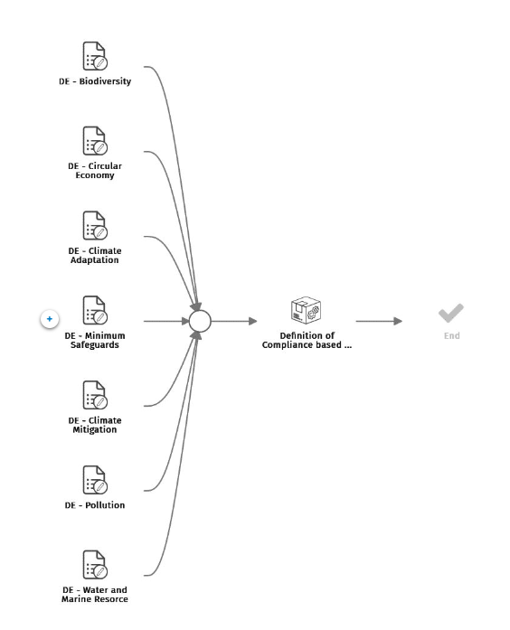

- DE Minimum safeguard, is aimed at the compliance assessment of the minimum social safeguard criteria provided by the regulation. Compilance is divided into four categories : Human rights, corruption ,taxation, Fair competition
- The Final Report on Minimum Safeguards issued by the Platform on Sustainable Finance provided the criteria formulated in the form of denial, for a Minimum Safeguards criteria to be satisfied, the compliance has to be positive (indicated with a green check mark).
- The task Definition of Compliance based on criteria performs the calculation based on the data uploaded and reports the results in the Economic Data Aligned form.
- The DTP in fact calculates the percentage of how compliant the company is.

Output

- Populate the FW based on what has been calculated in AIH.

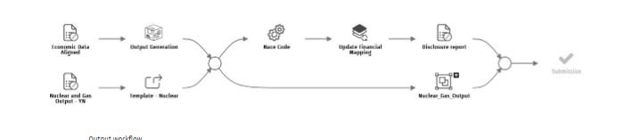
- Report economic data aligned contains the results of the calculation according to the logic of the process.
- The task output generation is responsible for the extraction of the Economic data aligned results and for the subsequent upload into the Disclosure Report as required by the EU Regulation.
- The report Nuclear and Gas Output – ANNEX XII contains the information referred to Article 8(6) and (7) and shall be presented as follows, for each applicable key performance indicator (KPI). The steps related to Nuclear and Gas, only need to be performed if activities have been set from NACE codes 4.26 to 4.31.
- The task Nuclear is responsible for retrieving the data from the AIH report Nuclear and Gas Output and uploading them into the official output CPM report Nuclear energy related activities.
- The Disclosure report is the output report required by the EU Taxonomy regulation (Delegated act 2021-4987 annex-1-5) filled with the results of the calculation logic, and uploaded from the Economic Data Aligned form. See below an example of a disclosure report.
- 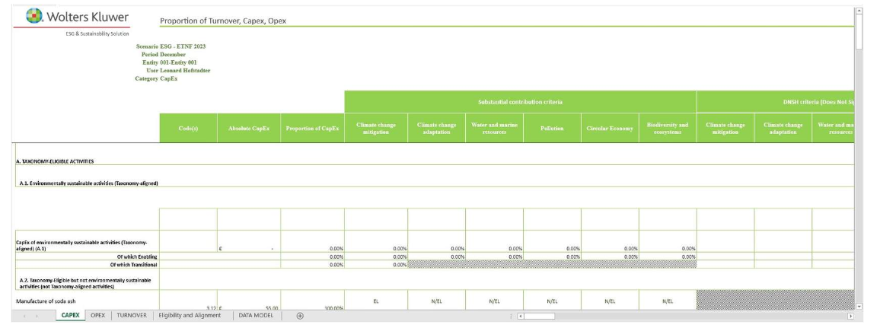

Consolidation
- The consolidation adjustments data entry tasks allows the consolidator to enter manual adjustments entries to integrate the data and the journals generated by the solution
- Thanks to the task consolidation, the consolidation engine aggregated the data of individual entities creating the group company. This way, we will have the consolidated values for the parent company.
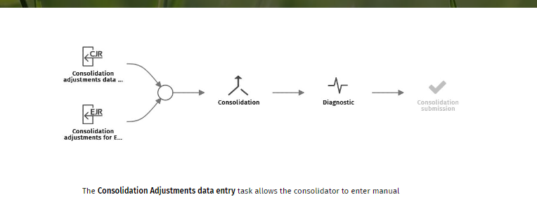

Consolidator view
This consolidator view is only available for the entity representing the group.
- Consolidated data transfer: Transfer the consolidated ESG data to the original amount
- CL : are aimed at recalculating the contribution percentage at group level.
- Delete the single entity CL to keep the CL at group level.
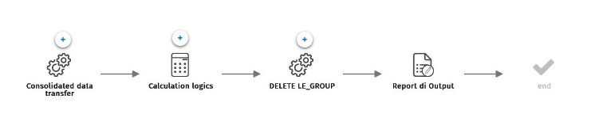

How to use ESG metrics &KPIs, IFRS, CSRD ?

The ESG Solution provides the management (data collection, calculation, and output disclosure) of KPIs required by the main reporting frameworks (e.g., GRI, SASB, IFRS, ESRS).
The ESG metrics & KPIs module includes the catalog of KPIs related to GRI and SASB reporting standards. The IFRS module includes the catalog of KPIs required by the IFRS reporting standard. The CSRD module includes the catalog of KPIs required by the ESRS reporting standard.
From a technical point of view, all three separate modules, ESG Metrics & KPIs, IFRS and CRSD, work in the same way. The main difference is within the materiality process, which follows a different path.
In this training, we will mostly focus on the CSRD (ESRS reporting framework) module.
Here, you will have a view on a workflow based on the Best Practice to calculate the required KPI’s and to generate the mandatory disclosure.

Materiality
- Need to evaluate the material topics
- Two different paths :
  - One for the ESRS reporting framework
  - Another for the GRI/other reporting framework, with some common steps.
  - 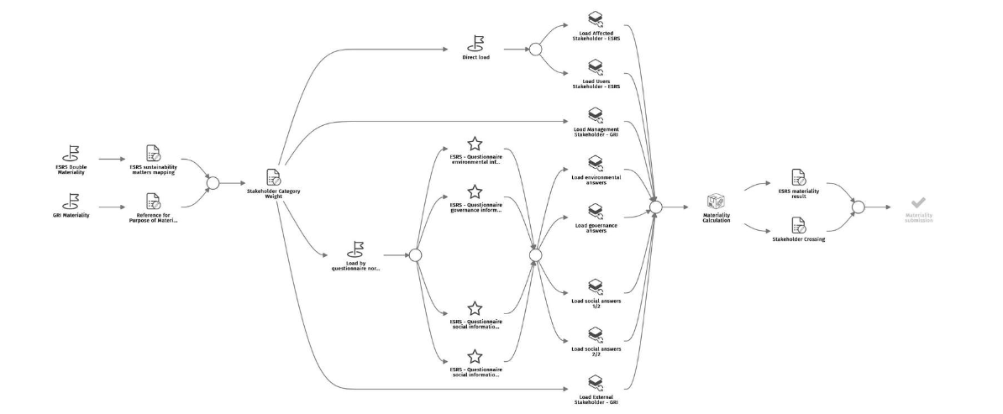
The pre-configured solution provides the possibility to perform Materiality assessment to evaluate material topics according to the process described in this paragraph.
The Solution also covers the double materiality assessment according to EFRAG’s ESRS requirements. This assessment must not be considered as a mere mandatory exercise. Instead, it is a tool that helps companies identify the sustainability matters that are material to them and gain a better understanding of the risks and opportunities associated. Moreover, the ESRSs state that materiality assessment is necessary to identify the material impacts, risks, and opportunities to be reported in disclosure. Sustainability matters that qualify as materials for the company may either belong from impact materiality, financial materiality, or both.
The materiality process affects people who mostly are not CCH Tagetik users, they can be internal or even external to the organization, for this reason, we do not use CCH Tagetik data entry forms to collect the information needed. It is necessary to use external tools that can be shared with non-users, such as Microsoft Forms.
Materiality elements (5)
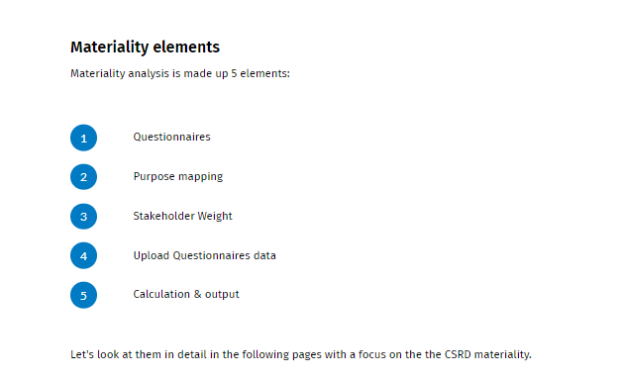

Questionnaires

The first element of materiality analysis is stakeholders’ engagement, through the tool of the questionnaires to collect relevant information to calculate materiality assessment.
The ESG Solution questionnaire structure is based on project experiences in the field while, for ESRS double materiality, questionnaires are based on the European Sustainability Reporting Guideline on double materiality.
The ESRSs define the materiality from an impact perspective and from a financial perspective:
- Impact perspective: 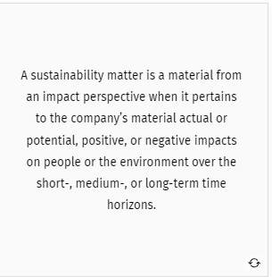<
- Financial perspective: 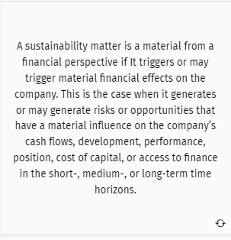
Stakeholders
The ESRs define two main stakeholder groups :
- Affected stakeholders
  - Individuals or gourps that are or may ne affected in a positive or negative way by the activities of the company
- User of sustainability statements
  - Primary users of general-purpose financial reporting as well as other users.
With the engagement of these stakeholders, companies can identify material sustainability matters and assess their actual and potential impacts, adopting thresholds to determine which of these impacts will be covered in sustainability statements.Companies shall also determine the severity of the impacts on sustainability matters, by assessing the scale, scope, and irremediable character of impact.
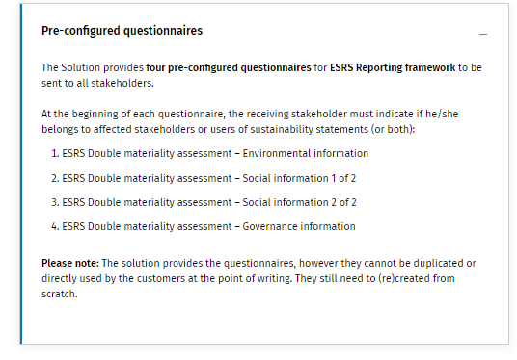

The Solution provides a questionnaire for affected stakeholders and a questionnaire for users of sustainability statements each of which contains five questions for each sustainability matter identified in ESRS 1 - Appendix B: Application Requirements – Sustainability matters covered in topical ESRS.
A given sustainability matter on this list is assessed to be material, and the company shall report according to the corresponding Disclosure Requirements of the relevant topical ESRS. Using this list is not a substitute for the process of determining material matters. This list is a tool to support the company’s materiality assessment. The company still needs to consider its own specific circumstances when determining its material matters.

The questionnaires has 5 different questions – 2 financial materiality and 3 impact materiality.
- Scale of impact: how grave the negative impact is or how beneficial the positive impact is for people or the environment, measured by an intensity scale
- Scope of impact: how widespread the negative or positive impacts are, measured by a scale
- Remediability of impact: whether and to what extent the negative impacts could be remediated, measured by a scale
- Continuation of use of resources: whether the company will be able to continue to use the resources needed in the business process
- Reliance on relationship: whether the company will be able to continue to rely on the relationship needed in the production process on the same current terms or whether the company’s practices will trigger an adverse reaction.

Purpose mapping, Stakeholder Weight, and Upload Questionnaires data
- Need to nap the question with the purpose of using report reference for purpose of materiality
- 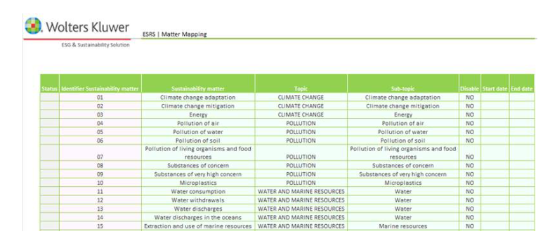
- It is also possible to fill in the form STAKEHOLDER CATEGORY WEIGHT to assign to each stakeholder a certain weight.
  - This report is used for double materiality but also for materiality assssement, for other reporting frameworks
  - 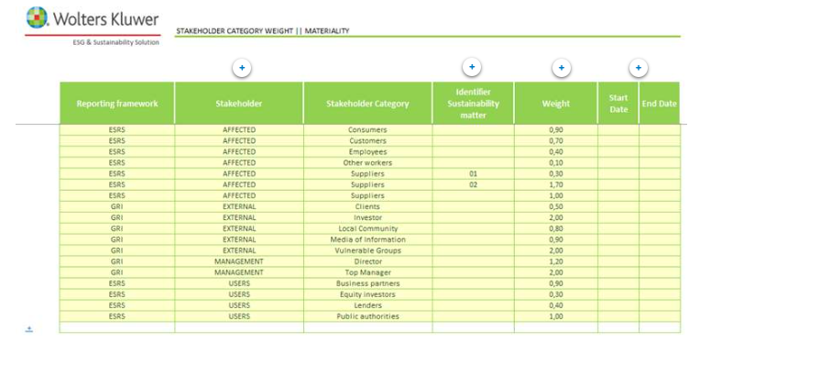
- Possible to quickly upload the questionnaires (solution provided this)
- 2 different kinds of uploads:
  - tt is possible to collect the answers from the affected stakeholders and from the users of the sustainability statements in the preferred format and manually set up the upload file (one file for each kind of stakeholder) via QDL.(Use the QSL
  - or an automatic elaboration that transfers the output excel obtained from the answers to Microsoft forms questionnaires to a pre required input format

Calculation and Output
The system does the materiality assessment as average weighted calculation, using the materiality calculation based on :
- the answers of the questionnaires
- The weights assigned to the various groups of stakeholders in the stakeholders category weight.
- The calculation is in common between ESRS double materiality and materiality calculation for other reporting frameworks.
- The result is shown in the Stakeholder Crossing report and in the ESRS Double materiality result, depending on the framework for which the materiality assessment is taking place.
- The material topics are identified based on the fact that they are above the dedicated parameter threshold that the admin user can set (on demand during the run of the calculation).
- The outputs are two reports of the materiality topics in which it is also possible, per each topic, to select relevant KPIs to collect and disclose:
  - Stakeholder Crossing : The Dataset shows the database with the data used for the calculation of materiality and on which the previous graphs are based. The rows highlighted in green are those for which the purposes have obtained a higher value than the chosen threshold. For these rows, in fact, it is possible to choose the KPIs to activate. The other rows, colored in gray are those for which the purposes have obtained a lower value than the chosen threshold.
  - ESRS Double materiality result:
    - The Dataset shows the database with the data used for the calculation of materiality and on which the previous graphs are based.
    - Even in this case, the rows highlighted in green are those for which the purposes have obtained a higher value than the chosen threshold. For these rows, in fact, it is possible to choose the KPIs to activate. The other rows, colored in gray, are those for which the purposes have obtained a lower value than the chosen threshold.
    - In the two weight fields is shown the average of the weights of the categories of stakeholders that have been chosen to answer the questionnaires.
    - It is appropriate to recall that the calculation of the results for materiality is conducted by multiplying the average of the answers collected in the questionnaire by the weight relative to that single category. So, the average weight is not used.
    - 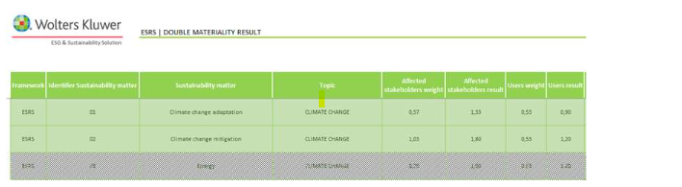

Settings
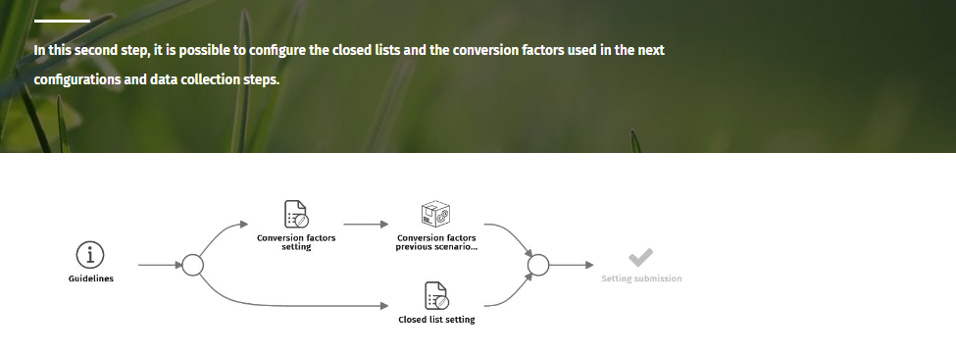
- Dictionary
  - Contains the elements of allowed values that are defined for a specific field.
  - Report is build on two tabs:
    - Pre configured elements
      - 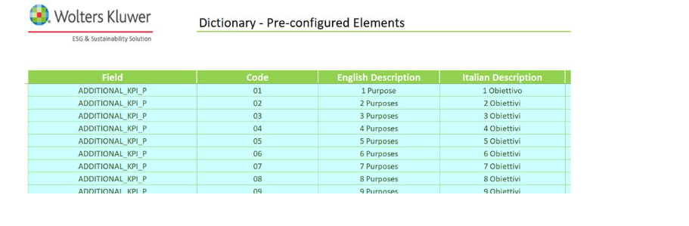
    - Custom elements
      - 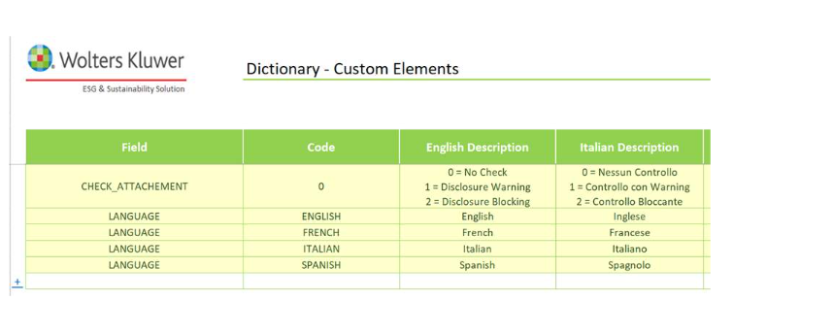
      - With the first installation package, some records for custom elements are provided in order to manage the check of Attachment and Language: Own custom dictionaries can be added here.
- Conversion Factors
  - In the conversion Factors form, the reference dataset is shown. This dataset collecte all the measures and related units of measures used in the process.
  - These measures have the purpose of converting values inserted during the data entry operation into the unit of measure required by the KPI for disclosure.

Data structure preparation
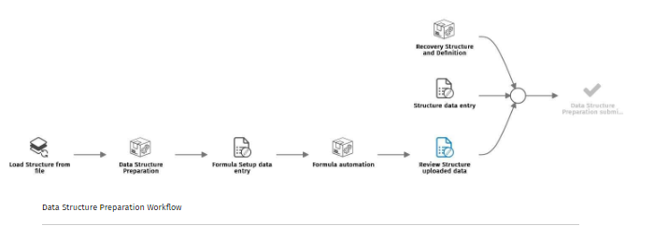

Structure and formula set up

Structure
The Structure report exists out of two tabs and the structure provided is the same in both. The main difference is the columns Disable KPI and Delete KPI and the editability of columns. In fact, the Pre-configured KPIs cannot be eliminated but only not reported, meanwhile, custom KPIs can be deleted from the Structure report.

In addition, to disable custom KPIs it is possible to use the fields Start Date and End Date. This way, it is possible to disable the KPI without deleting it.
Pre configured KPI are given with the ESG solution and cannot be modified except those one :
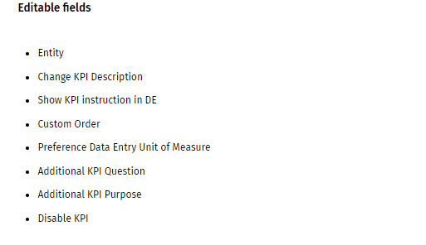
It is also possible to make Custom KPI’s
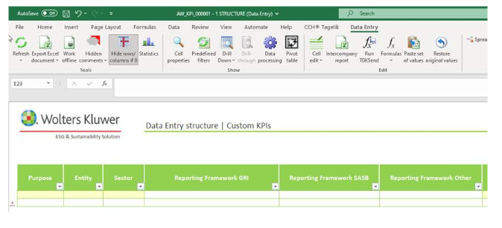

Formula Setup

The Formula Setup report is used to set up formulas used in the solution, previously managed in Definition, while the indication that a KPI is calculated is now given directly in Structure.
4 different tabs:
- Preconfigured KPI: collect the formula of pre configured KPI’s
- Custom KPI: collect the formula of custom KPI’s
- Query DEF: It comes from Definition and its main field is Utility. It is a code that provides indications on how a certain KPI can be identified inside the report and it is given by the combination of Disclosure, Grouping Level, and Rank row, between “square brackets” and coordinates are comma separated (e.g.: [GRI_301-1,A,1] to indicate the first row of grouping level A in for disclosure GRI_301-1).
- Query STR: It comes from Structure The difference between the previous tab and this is that in Query STR you will find all the no-detailed KPIs.
There are two types of calculated KPIs:
- CALC_ALL: for KPIs calculated for consolidated entity and not
- CALC_SOLO: for KPIs calculated for not consolidated entity

The Applied formula column (both in Pre-configured KPIs and in Custom KPIs) is where users need to specify the formula to be used to determine the result of a KPI that can be derived from other KPI values. The content can be freely inserted even if it is important to follow correct grammar to produce a correct result.
The KPIs that need to be indicated inside the formula need to be defined as shown in utility (e.g.: [GRI_301-1, A,1]) or in case of calculated KPI based on “reference KPIs” is in the same “box”, it is possible to indicate the first only the rank rows (e.g.: [4]).

The field Automated formula includes the formula syntax as required by the Solution, applying the new product feature of Calculation Rules, available from CCH Tagetik SP 25.

Subsequemt iterations
- Need for each quantitative KPI the level of detail of collection.
The Definition report is the tool used to specify, for each KPI quantitative, what levels of detail must be collected and reported, and for which values these levels are broken to proceed with data entry operation in the Data Collection phase.
The structure given to this report is obtained from the Structure report, as it is possible to see in the image below looking at the attributes framed in 1, 2, and 3.

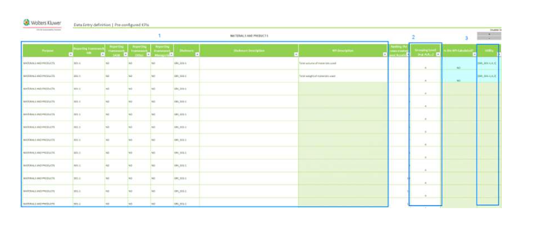
Two different tabs :
- Pre configured KPI: all the quantitative KPI required by a regulaor or a reporting framework settler
- Custom KPIs: customer configures his own indicator added before
In both tabs, the structure provided is the same, the only difference being that the columns refer to Custom level. In fact, in the Custom KPIs there is no possibility to add custom level, the respective elements, and consequently the restrictions on KPI because this sheet is all customized.
Pre-configured KPIs are provided together with the ESG Solution and cannot be modified, excluding some fields that are editable:

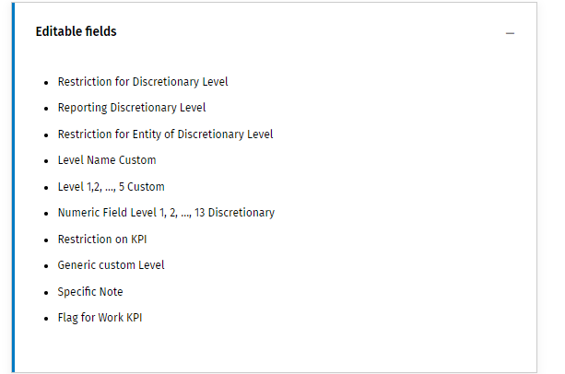

Declarations
This following step allows to change the status of each purpose in order to modify them in Structure or Definition to begin the data entry phase, including features to add or translate KPIs and to translate generic elements of breakdown details. It also includes tasks regarding the configuration of control groups of consistency, existence, and congruence.
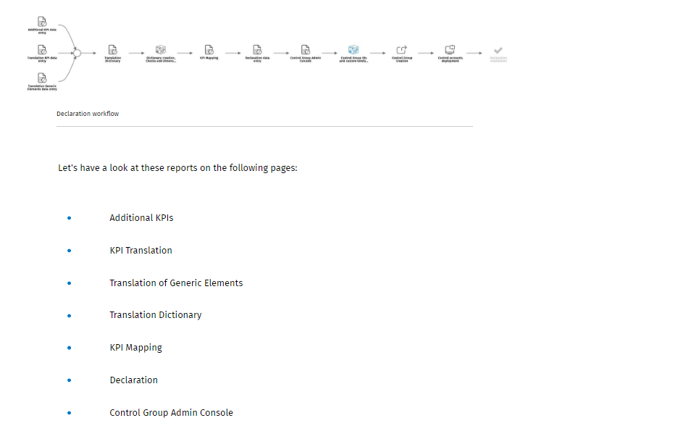

Additional KPI and KPI Translation
Manage :
- Instructions : clarify the compilation
- Additional question: collect additional info for qualitative KPI
- Additional puerposes report a qualitative KPI for other purposes
When the report is open, it is possible to see that 3 different colors have been chosen to better distinguish the rows that refer to purpose, question, and instruction.
It is possible to view in white the rows that refer to questions; in light red the rows that refer to purpose and in gray the rows that refer to instruction.
This report allows the customization of the KPI description.
It is necessary to fill “YES” in the field “Change KPI description” and verify that the end date is null and that the interested KPI is not disabled in Structure. It is possible to fill in with “YES” only if the Regulatory KPI field is set with "NO". In this case, a new row will be created in this report.
The structure given to this report is obtained from the STRUCTURE report, as it is possible to see in the image below looking at the attributes framed in 1 and 2.

Translation of generic Elements
- This report is used to assign proper values to generic elements used inside the Definition report during the level breakdown specification task, allowing to specify in a second moment levels’ value attribution. The values specified would be applied in the process starting from the Data Collection phase.
- 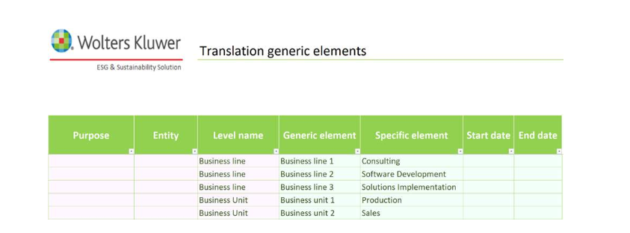
- For example, as shown in the screenshot above, the generic element ‘Business line 1’ in the DE report will be translated with the specific element ‘Consulting’; the ‘Business line 2’ with 'Software Development' and the ‘Business line 3’ with ‘Solution Implementation’.
- To configure these elements, it is necessary to fill in the field Level name with what is entered in the Definition report, then choose for the Generic Element field one of the options provided, and finally insert the translation that will used in the report of 'Cross Deployment' and 'Data Entry'.
- It is also possible to restrict the translation only for specific purposes and entities filling in the relative two fields with the necessary options. To better explain if the Generic Element ‘Country’ is used for more than one purpose, such as Emissions and Tax, and in this report, these elements are translated only for Emissions purposes, in the Tax Data Entry report will not be found these elements translated. Instead, it is also possible to insert different translations for different purposes and entities. In this case, one row without a specific Purpose and Entity must exist.

Translation Dictionary and KPI Mapping
This report is used to translate the elements of configuration reports, to be used in the Data Entry and Output reports.
To have the possibility to correctly use translation in the Data Entry and Output reports it is needed to fill this Dictionary Translation report with a description for each language enabled. This could be done just after the other configuration reports have been filled, but before generating the data entry reports.
Inside the report two different tabs with the same structure are available
It isn’t possible to add new rows manually. To have all possible translatable elements it is necessary to save the configuration reports.

This way, all the new lines for which it is possible to insert a translation will be added to the report. The new rows will have the Description column populated even if the description has been inserted in another language. It will be up to the admin user to enter the description in the correct language column in case they need to view the reports in another language.

KPI Mapping
If two different quantitative KPI are related, it is possible to make a mapping.

Declaration and Control Group Admin Console

This report is used to lock or unlock the editability of the data present on top of the configuration reports.
So, this report can be used to:
- Close the status of the purpose to start Data Entry
- Re-open the status of the purpose to allow the user to edit reports useful to the configuration of the solution (such as Structure, Definition, Translation Generic Elements, Translation KPI, Additional KPI, and Conversion Factors)
The report contains different data-quality checks that must be OK in order to be able to change the status for a purpose. The first one indicates if there are errors in the Structure report, the second and third make the same check but for the Definition report and Dictionary Translation report.
The system, after saving the Structure report, creates a database account for each KPI that can then be used to define the process and user limitations. The account is assigned to the hierarchy which is divided by purpose. This is thanks to an ETL which created this account.
An account is created for each Header KPIs and Additional purpose too. Accounts for additional purposes are created after saving the Additional KPI report and are necessary for both user limitations and process definition. After their creation, a node in the hierarchy of accounts is also created.

Control Group Admin console
Within the Control Group Admin Console, the Solution allows us to set pre-configured or custom control groups. The report pre-fills fields PURPOSE and DISCLOSURE (the latter through a launch parameter) and then it is possible to choose the impacted KPI. Depending on the type of control, some fields will be activated (e.g., Lower Tolerance (%) and Upper Tolerance (%) for consistency checks, or Element of Equation and Formula for congruency checks).

- Consistency checks regarding current period amounts vs previous period amounts, according to a pre-set tolerance threshold. Upper and lower tolerance thresholds should be entered as a percentage of the previous period value.
- bullet
Existence checks, which verify that the amounts are different from 0. In this case, simply define the type of check and description.
- bullet
Congruence checks allow us to conduct checks based on formulas defined by the user. They also allow cross purpose and disclosure checks. To define a control of this type, you need to define as many rows as there will be aggregates to check (e.g., I want to verify that KPI1 is greater than twice KPI2).

Cross elaboration :
This step allows you to generate or update Data Entry reports and then fill in Data Entry reports. In addition, the contributor user can use the feature to massively upload data using an ad-hoc report. It also allows users to activate or disactivate the elements of levels to create the crossings for the data entry and to proceed with the data entry.

This task includes all the activities necessary to create the Data Entry reports and the Cross Deployment report.
It creates the report if it has never been generated before, otherwise proceeds with updating it, if changes have been made to the reports described above.
- Specifically, it inserts all the KPIs listed and managed in Structure and Definition including of course the header KPIs type or modifying those for which the description has been changed.
- In addition, it also adds additional questions and instructions to the KPIs for which they were requested and if additional purposes were also requested, it adds the respective KPIs to the purposes mentioned in the Additional KPIs report.
- It also changes the description of elements of the levels if a translation has been given in the Translation Generic Elements report. To summarize, all types of KPIs are inserted except calculated KPIs, which will be listed in the Output report where the formulas set in the Definition report and the conversion factors set in the Conversion Factors report will be applied.
- Finally, it allows us to view the values of the previous period where present.
To generate the “ESRS Data Entry report” and “IFRS Data Entry report” the same procedure can be done but using “ESRS Cross Elaboration” and “IFRS Cross Elaboration”. The only difference between other Data Entry reports is that in this case there is a unique Dataset that refers to all ESRS topics and a unique Dataset that refers to IFRS ones.

Cross Deployemnt data Entry
This form provides the user, if this is allowed within the process, with the availability to disable some elements of levels for the selected disclosure.

Once the user is logged in and the report is created by the administrator user, if the end-user wants to do Data Entry for each combination of elements of levels created, they can immediately start entering values in the DE report. Otherwise, to disable some elements it is necessary to use the link that is on the report in order to enter, using the same parameters chosen before, the Cross Deployment report.

The first action is to use the flag, save the report, and then click on the elaboration Update Data Entry via its own button (1, 2). To disable an element it is necessary to use the closed list shown below and choose the – 1 value.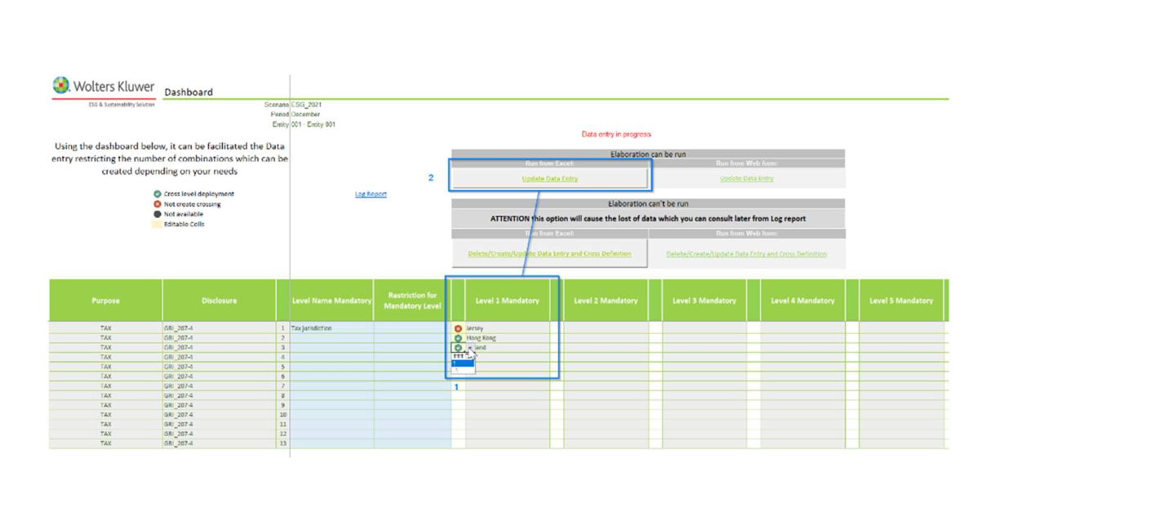

ESRS Data entry and Data entry by form
- Data entry operation of the KPI in the Setting is done via DE form
- The name of the purpose referred to is indicated at the top of each report. There are also four cell fields that give information about the scenario, period, entity name, and business entity name for which the report was launched.
- The Data Entry report is now available and ready to be filled on the yellow-backed cells, as pre-defined before the element ‘Jersey’ has been disabled. In fact, it's possible to see that this is not found in the DE report, and nothing will be reported for it.
- After the dataset has been generated, it is possible to put the desired values together with the Unit of Measure on yellow-backed cells. The Unit of measure of the amount inserted can be chosen using a drop-down menu where a closed list of values can be used (e.g.: the only possible values for Numeric can be made are number or day).
- 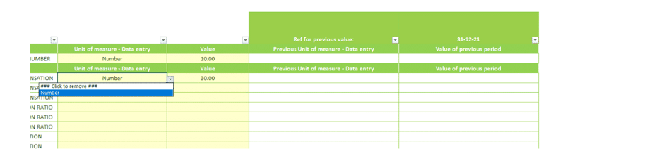

KPI conversion and calculation and output creation
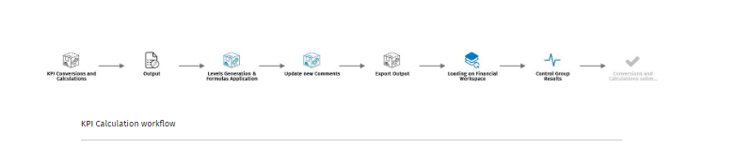
Within this phase, the measures of KPIs are converted and calculated according to the parametrization provided and to the data collection. The step also allows to checking of the results of control groups previously set on output data. Furthermore, in this step, it is possible to consolidate/aggregate KPI amounts in a single GROUP legal entity that represents the whole group.
It is needed to select a purpose or all depending on whether just one purpose should be run or the calculation for all of them
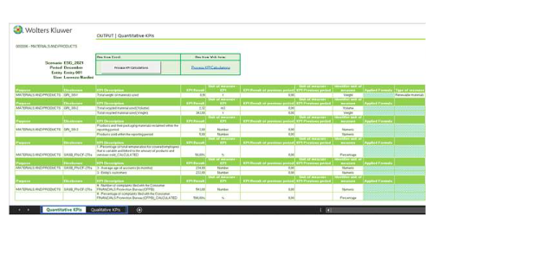
The report provides all the results for every KPI displayed in the file in the required unit of measure and for KPIs based on the formula, all the main reference coordinates are represented to give a better understanding of final outcomes. The value of the previous period is also reported.
KPI levels, both mandatory and optional, are reported for more omni-comprehensive data disclosure.
This report is Read-Only, just to view the outcome’s value produced at the very end of the process.
ESG Solution provides a dedicated functionality to generate output templates, creating them following customers needs based on 31 analytical dimensions. The ESG Solution provides additionally a set of ESRS-CSRD Output reports suggested by the Regulation that not mandatory but recommended by the Regulation.

Centralized Contribution Set up :
- The centralized contribution setupt step : the admin configures the solution to allo the user to enter data on a single dataset and then distribvut these data into du purpose datasets.
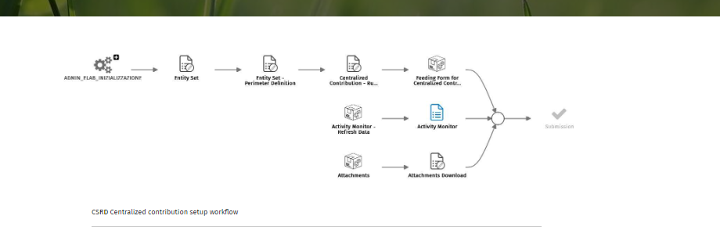

- Entity set The Entity Set report allows the census of company sets. Through this report, the Admin user defines the code and descriptions for each set of companies.
- Entity set – perimeter set up:
  - Permit define the set of companies belonging to the group surveyed using the previous report.
- Rule definition
  - The admin has the possibility to define the contribution rules at various lebels on the various sets of specified entitres.
  - Those rules can be defined at the level of purpose, disclosure and KPIs
- Activity monitor
  - The activity monitor is a report that shows for entity/purpose/disclosure, the last user that perfoed an action

Centralized contribution – ESG ambassador

This step allow user to make data entry on a single dataset and then distribute thses data into due purpose dataset

KPI Consolidations
- There is an AIH conso tool that does not use the regular CCH Tagetik Conso tool.
- This allows the user to run the process in distinct phases: both at a single entity stand alone and at the consolidated level by aggregating in the single entity Group the same input dat collected by the contributor entities.
- The aggregated data are then included in the normal process of KPI calculations and output generation.

Consolidation admin console
This report is used to define the consolidation area and the data aggregation rules for purpose and disclosure.
The consolidation of KPIs takes place within the KPI xconversin and calculation DTP. CONS_INPUT dataset draws out from CALCULATION dataset data of contributor entities, while in CONS_DATA dataset all partitions and all contributor data are transferred and aggregated by GROUP legal entity, with evidence of the original contributor entity.

Takeaways :

- SASB and GRI are both Integrated Reporting frameworks.
- CSRD and EU Taxonomy are part of the Regular reporting frameworks.
- 6 modules are offered by the ESG Tagetik solution (see above)
  - Big focus has been made on EU Taxoomy
- Both AIH and FW are used
  - AIH for setting, data collection and calculation
  - FW for disclosures and conso purposes
- For Credit institutions :
  - The ESG Solution provides the necessary tools to manage EU Taxonomy requirements till 31.12.2022 reporting date and to manage EU Taxonomy requirements starting from 31.12.2023 report
- For insurance and resinsurance undetakings
  - The ESG Solution provides a separate Analytical Workspace and specific rules to manage the EU Taxonomy requirements for Insurance and Reinsurance undertakings.
- For non financial Undertakings
  - The EsG solution provides AIH with some default configurations and specific rules to manage EU taxonomy for non financial undertakings
- The ESG Solution provides the management of KPIs required by the main reporting frameworks, such as GRI, SASB and ESRS.
- From a technical point of view, the modules ESG Metrics & KPIs and CSRD work in exactly the same way.
- The ESG Metrics & KPIs module include the catalogue of KPIs related to GRI and SASB reporting standards. The CSRD module includes the catalogue of KPIs required by ESRS reporting standard.

